Pesticide Water Calculator 3

User Manual

# Introduction

The Pesticide Water Calculator 3 (PWC3) is a tool for calculating pesticide concentrations in waterbodies for use in risk assessments as typically used in government regulatory work. PWC3 is a major upgrade from earlier PWC versions and should allow for much greater productivity, especially when spatially and temporally comprehensive assessments are desired. To focus on productivity, the user interface is streamlined with only the most necessary inputs brought forward for user interactions. Parameters that are seldomly altered and those that should not be altered for standard risk assessments are placed in a secure and less distracting location. PWC3 is also much more computationally efficient as portions of the program have been revised to improve speed and eliminate unnecessary text file read and writes. Massive batch run capabilities that the regulatory community is trending towards have been added. These new capabilities include batch runs with multiple applications methods, various application timings, multiple scenarios, and multiple water bodies. PWC3 addresses the newer ways for conducting regulatory water exposure assessments.

## Conceptual Model Overview

The conceptual model that USEPA uses is shown in Figure 1. A detailed description of the mechanics of the model can be found in Young (2023) and a high-level overview in Young (2019) but briefly, the conceptualizes an agricultural field with a crop and an adjacent water body. After pesticide is applied to a field, subsequent rainfalls or irrigation will transport pesticide to an adjacent waterbody transport by runoff and erosion. Pesticide aerial drift may also apply on the day of application. The model accounts for typical degradation and dissipation process such as metabolism, volatilization, photodegradation, leaching, uptake into sediment, and washout.

Figure 1. Conceptual Model for PWC3

# Interface Overview

PWC3 inputs are organized by tab pages, with the main pages showing by default at startup. The main tab pages are Chemical, Watershed/Waterbody, Schemes, Applications, and Scenarios. These tab pages are discussed in detail below. At the top of the interface is a menu bar with File and More Tabs. Work can be saved at any time by selecting File then the subitem Save. Likewise previous work can be loaded by selecting File then Retrieve. The More Tabs item gives users the option to open more less frequently needed tabs for advanced work; these tabs are for advanced users and is discussed in detail below. The Calculate button on the bottom right starts the simulation. On the lower left are locations and names of your saved work which become populated after you use File/Save or File/Retrieve. For convenience, you can double clicking on the directory path in the lower left will open that directory in a Windows browser. Your output and input files will be in this directory.

## Saving and Retrieving Work

The File menu item has two subitems Save and Retrieve. Saving work with File\Save will open a standard Windows file browser requesting you to *Save As.* All saves are Save As to help with accidently making unintentional saves. The *Save As* command will specifically request the name you want to use for the file save and will again ask if you are sure about this. Work is saved by default in a file with a PWC extension (e.g., *anyfilename.PWC*). However, it is not necessary to use this extension if a user needs to change it say for some advanced application. Input files are plain text files with a structure detailed in the PWC3 Technical Manual (Young, 2023). Input files can be easily examined or edited with any text reader. External editing though should be done with caution and only by advanced users. Previously saved files can be loaded with File\Retrieve. The default extension is PWC, but PWC3 can read any file as long as it is a text file with the proper structuring. Whenever File\Save or File\Retrieve are used, the directory path at the lower left will be populated with the path corresponding to the Save or Retrieve location. This location is where all output will be delivered at the end of a simulation. A convenient feature is that the path itself can be double clicked so that a user can easily access that location.

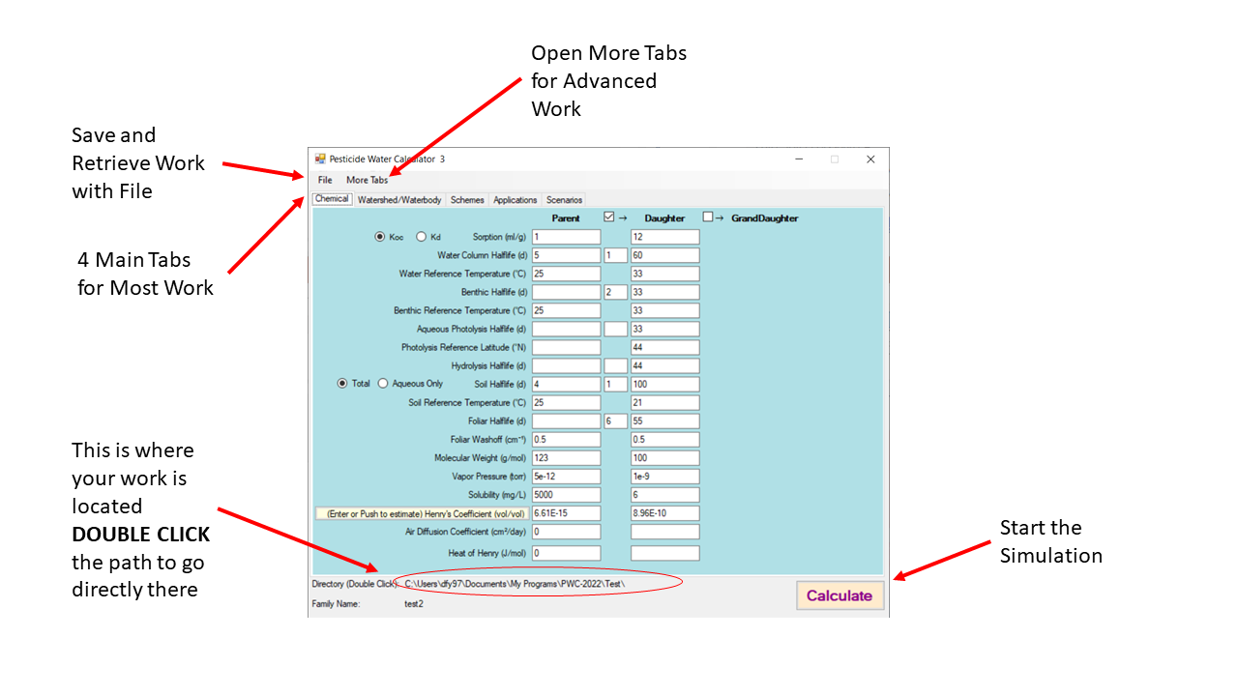

Figure . PWC Main Features

## Chemical Input tab

When the program starts up, the input screen will appear as in Figure 2. There is a column of chemical inputs that will be used for every simulation in a run. These inputs are for the primary (or parent) compound, that is it is for the chemical that will be directly applied to the field. Degradate properties will be discussed later in this document. Most properties can be left blank if information is unknown, in such cases, the function will be disabled for that process. For example, if hydrolysis is left black, the effective degradation rate for hydrolysis will be zero (i.e., infinite half-life). For the case where a parameter must be populated, the program will alert the user to enter a value. Details of the chemical inputs are as follows:

Figure . chemical inputs for parent

**Koc or Kd** – choose Kd if the sorption input is the standard sorption coefficient referenced to total solid mass. Choose Koc if the sorption input is referenced to organic carbon mass. These are well-known standard definition available in any environmental chemical transport reference.

**Sorption (mL/g)** this is the value of either Kd or Koc

**Water Column Half-life (d)** – this is a value for water column degradation that acts on all phases of the compound. The water column, as described elsewhere, contains suspended solids and other material that can sorb the chemical. This water column degradation parameter will act on these sorbed chemical phases as well as any dissolved in the water phase.

**Water Column Reference Temperature (°C)** This is the temperature at which the Water Column Half-life was obtained. This temperature is used as a reference when adjusting the degradation as environmental temperatures change during a simulation.

**Benthic Half-life (d)** – this is a value for benthic degradation that acts on all phases of the compound. The benthos, as described elsewhere, contains solids that can sorb the chemical. This benthic degradation parameter will act on all chemical phases in the benthos.

**Benthic Reference Temperature (°C)** This is the temperature at which the Benthic Half-life was obtained. This temperature is used as a reference when adjusting the degradation as environmental temperatures change during a simulation.

**Aqueous Photolysis Half-Life (d)** This is the near surface half-life due to photolysis of the chemical dissolved in water. It should be the overall daily average value optimally best representing the daylight hours when the pesticide is most actively in the environment, but 12 hours of light would be a fine assumption.

**Photolysis Reference Latitude (°N)** This is the latitude that the photolysis study is meant to represent. This latitude is used as a reference when adjusting the degradation for different locations.

**Hydrolysis Half-life (d)** – this is a value for degradation by hydrolysis. This parameter acts only on the aqueous phases in the model. It is effective in both the water column and the benthic region. There are no temperature adjustments on this parameter.

**Soil Half-life (d)** – this is a value for total soil degradation. Depending on the radio button that follows, this can act on all phases of the compound (water and sorbed) or just on the water phase.

**Total or Aqueous** Determines whether the soil degradation ass calculated as a total degradation rate or as an aqueous-only rate.

**Soil Reference Temperature (°C)** This is the temperature at which the Soil Half-life was obtained. This temperature is used as a reference when adjusting the degradation as environmental temperatures change during a simulation. (IS it on or off?)

**Foliar Half-life (d)** – this is the degradation half-life of chemical that is on the foliage. This is chemical half-life and should not include washoff due to precipitation. It could include dissipation due to volatilization if that information is available.

**Foliar Washoff (cm-1)** Washoff coefficient that specifies the fractional removal of chemical on foliage that rain removes for every 1 cm of precipitation. PWC suggests a value of 0.5, as this information is typically not readily available. The USEPA has used 0.5 as a default value for the past 30 years in PWC-type exposure assessments.

**Molecular Weight (g/mol)** common molecular weight

**Vapor Pressure (Torr)** vapor pressure of compound (preferably at standard temperature, 25°C)

**Solubility (mg/L)** solubility of compound (preferably at standard temperature, 25°C)

**Henry’s Coefficient (vol/vol)** volumetric Henrys coefficient (preferably at standard temperature, 25°C)

**Air Diffusion Coefficient (cm2/d)** Diffusion coefficient of the chemical in air

**Heat of Henry (J/mol)** Enthalpy of phase change from water solution to air solution

### Daughter and Granddaughter

Checking the daughter and the granddaughter boxes will allow entry and calculation of direct degrates of the parent chemical as shown in Figure 3. Definitions of inputs are the same as for the parent. For each degradation process there is an entry required to specify how many moles of the degradate is produced per mole degrading of the preceding chemical. For example, if hydrolysis of one mole of parent produces 2 moles of daughter, then the box between parent and daughter on the hydrolysis row should be populated with 2.

Figure . Degradate Inputs

## Watershed/Waterbody Tab

This tab specified the type of waterbodies that receive the chemical coming off the field. PWC 3 has 2 hard-coded waterbody systems that are standard for USEPA risk assessments—the Farm Pond and the Reservoir. See Figure 4. These two waterbodies can be simulated by checking the respective box. In addition, any number of custom water bodies may be run by selecting the proper file that describes the waterbody. Creation of water body files will be described later. To select waterbodies other than the pond and reservoir, use the *Select Water Bodies* button. This will open a file browser which allows you to choose any number of previously-created waterbody files. Waterbody files all have the extension WAT. These WAT files are plain text files that can be created by means discussed later. Waterbody files can be removed from the list with the self-explanatory Clear Selected and Clear All buttons. Users can select as many hard-coded and custom waterbodies as they need, and all will be processed in a single run.

Figure . Waterbody choice

## Schemes

Scheme allow different application types and different scenarios to be simulated and processed in a single run. A scheme is the combination of a specific application schedule along with all the scenarios that it applies to. For example, one scheme could be obtained from a pesticide label that says “Apply 1 lb. per acre to all corn across the continental United States”. Another scheme could be to “Apply 1lb/acre and then 1.5 lb./acre 7 days later to radish in the Southeast”. The number of schemes that can be simulated is unlimited, and rows will appear as needed as rows are populated. By using schemes, all the possible uses of a pesticide can be simulated in a single run.

To create and edit schemes:

Open the Scheme Tab and give a description of the scheme you wish to create (see Figure 6). The description has no effect on the program, it is for your reference only. But, the description should provide enough information for you to easily identify its characteristics. This scheme description will remind you on later tabs which scheme you are working on. Scheme descriptions are not recorded in output displays, since the text would be too long; instead, schemes are identified in the output by the *Scheme Numbe*r in the first column.

Checking the edit box will allow you to create and edit the scheme properties on the Applications and Scenarios tabs. The Commit button commits the edits to volatile memory. This means the edits will apply to the current simulation but will not be saved if the program is shut down. To permanently save any work, Use the File\Save command after any commits are made. The *Delete* button removes the scheme from the run. The number of schemes is unlimited, and more rows will appear as needed as rows are populated

Figure . Schemes summary page

After checking the Edit box for the scheme you want to create or edit, open the Applications Tab (see Figure 7). At the top on the Tab you will see the Scheme Description that you previously entered. This will help you keep track of the scheme that you are working on. Preceding the description is a number that corresponds to the row number of your scheme, another convenience for tracking for those cases where you have many schemes. Enter the application specifics for the pesticide on this Tab as follows:

Choose the Application Units wither lb./acre or kg/ha

Any time that a scheme is changed, you must press the commit button next to the scheme to save the changes. **Importantly, commits are saved in volatile memory for the duration of the session (just like any text box). If you want to permanently save the commits (or any text box changes), then save your work to a hard file with the File/Save command.**

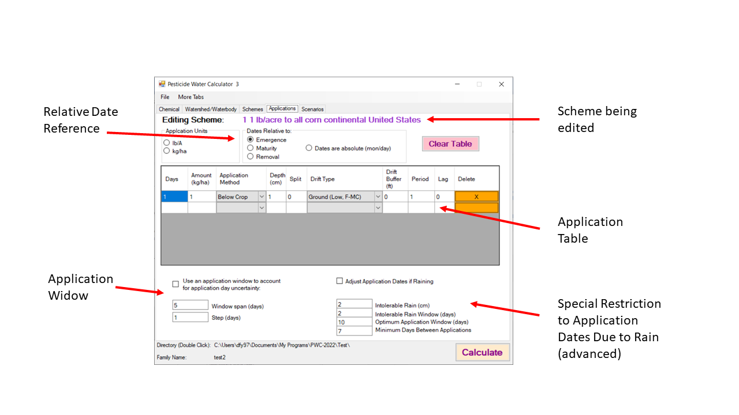

Figure . Application Tab for Scheme #1

# Output

Figure

Scenario Input Files are now separated in a manner that makes multi-runs easier. Inputs are separated into field inputs and watershed inputs.

## Field Input Files

Scenario input contain all intrinsic properties of the field. These include all area-independent parameters. Because these files are completely independent of the waterbody and extrinsic watershed properties, they can be used with any waterbody.

## Waterbody/Watershed Input Files

This file defines the extrinsic properties of the watershed. These include scale dependent parameters such as field size, hydraulic length, waterbody size, and drift parameters.

